Q1. WAP in C++ to print 1 to 10.

Q2. WAP in C++ to print sum of first 10 natural nos.

Q3. WAP in C++ to print sum of first 10 odd nos.

Q4. Write a C++ Program for Fibonacci Series Using Recursion.

Q5. Write a C++ program to input two numbers and check whether they are twin prime numbers or not. Hint: Twin prime numbers are the prime numbers whose difference is 2. For example: (5,7), (11,13), ....... and so on.

Q6: Using the switch statement, write a menu driven program in C++

1. To check and display whether a number input by the user is a composite number or not (A number is said to be a composite, if it has one or more than one factors excluding 1 and the number itself). Example: 4, 6, 8, 9…
2. (ii) To find the smallest digit of an integer that is input: Sample input: 6524 Sample output: smallest digit is 2 For an incorrect choice, an appropriate error message should be displayed.

Q7. Create a class named 'Rectangle' with two data members- length and breadth and a function to calculate the area which is 'length*breadth'. The class has three constructors which are :

1 - having no parameter - values of both length and breadth are assigned zero.

2 - having two numbers as parameters - the two numbers are assigned as length and breadth respectively.

3 - having one number as a parameter - both length and breadth are assigned that number.

Now, create objects of the 'Rectangle' class having none, one and two parameters and print their areas.

Q8. WAP to design the Triangle class.The class should have member functions like calc_area, calc_perimeter. Make assumptions, if necessary.

Q9. Given that an EMPLOYEE class contains the following members:

a. Data Members: Employee_Number, Employee_Name, Basic, DA, TA, HRA, Net_Sal

b. Member Functions: to read data, to calculate Net_Sal and to print data members

Write a C++ program to read data for ‘n’ employees and compute the Net_Sal of each employee.

Q10. Write a C++ program to create a class called COMPLEX and implement the following functions that return a complex number:

add (a, S2) – where ‘a’ is an integer (to be added to real part of S2)

add(S1, S2)

sub(S1, S2)

sub(S1, b) where ‘b’ is an integer (to be subtracted from real part of S2)

prod(S1, S2)

where S1 and S2 are objects of class complex.

‘a’ and ‘b’ are two integers.

Q11. A special two-digit number is such that when the sum of its digits is added to the product of its digits, the result is equal to the original two-digit number.

Example: Consider the number 59.

Sum of digits = 5 + 9 = 14

Product of its digits = 5 x 9 = 45

Sum of the sum of digits and product of digits= 14 + 45 = 59

Write a C++ program to accept a two-digit number. Add the sum of its digits to the product of its digits. If the value is equal to the number input, output the message “Special 2-digit number” otherwise, output the message “Not a Special 2-digit number”.

Q12. Create a class called user_time that has separate integer members for hours, minutes and seconds. One member function should initialize this data to 0, and another should initialize it to fixed values. Third should get the values from the user. A member function should display it in HH:MM:SS format. The final two member functions should add and subtract two objects of time passed as arguments. A main () program should create two initialized user_time objects. Then it should add the two initialized together, leaving the result in the third user_time object. Finally it should display the value of third variable.

Q13. Write a C++ Program to Add Two Complex Numbers by Passing Structure to a Function.

Q14. W.A.P in C++ by defining a class to represent a bank account. Include the following -

Data Members

● Name of the depositor

● Account number

● Type of account (Saving, Current etc.)

● Balance amount in the account

Member Functions

● To assign initial values

● To deposit an amount

● To withdraw an amount after checking the balance

● To display name and balance

Q15. Write a program using class to process Shopping List for a Departmental Store. The list includes details such as the Code No and Price of each item and performs the operations like Adding, Deleting Items to the list, and Printing the Total value of an Order.

Q16. Write a C++ program to create the class student having three data members denoting the student roll number, name, and marks. The object Count data member is a static data member that contains the number of objects created of class Student. Student () is a constructor that increments object Count each time a new class object is created.

There are 2 member functions in class. The function get_data() obtains the data from the user and put_data() displays the data. In the function main(), there are three objects of class Student i.e. s1, s2 and s3. For each of these objects get_data() and put_data() are called. At the end, the value of object Count is displayed.

Q17. Print the following patterns: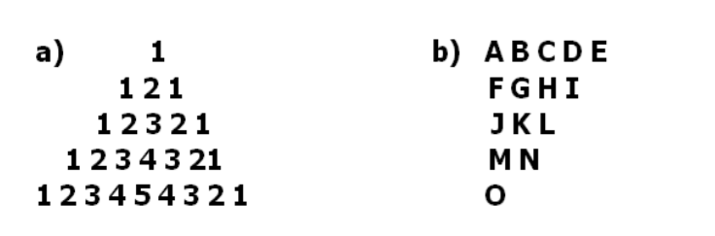

Q18. Create a class called distance that has separate member data inches and feet. One constructor should initialize this data to 0, and another should initialize it to fixed values. A member function should display it. The member function should add two objects of type distance passed as arguments. [ 1 feet =12 inches] Implement the class in main().

Q19. Write a program in C++ that can show the concept of function overloading via a number of functions, that can add two double variables, two float variables, two integers and return their sum.

Q20. Wap in C++ to add two complex numbers using friend function.